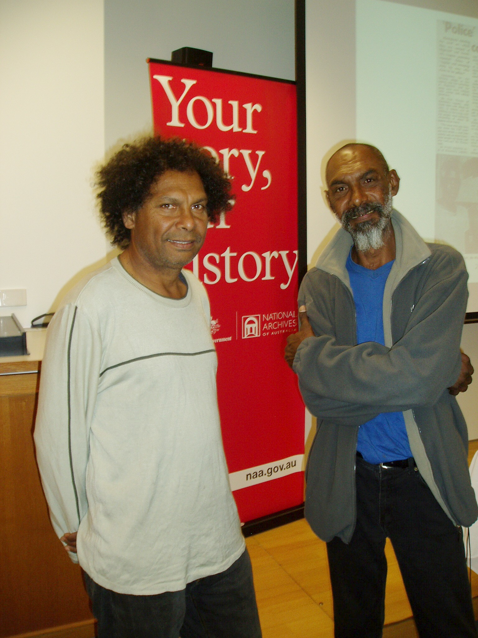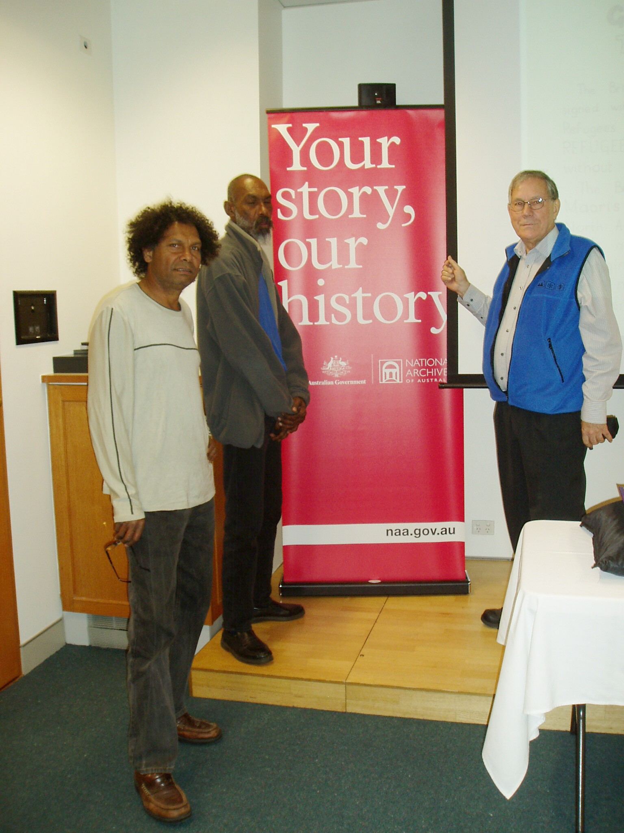

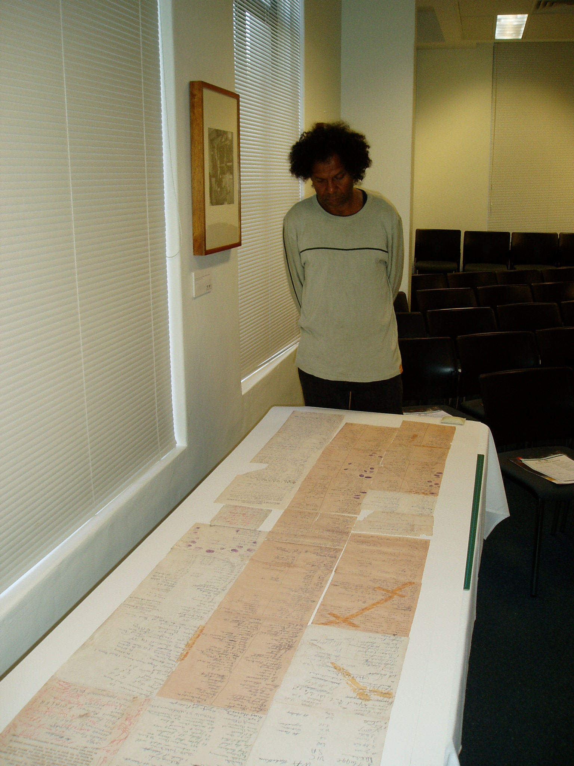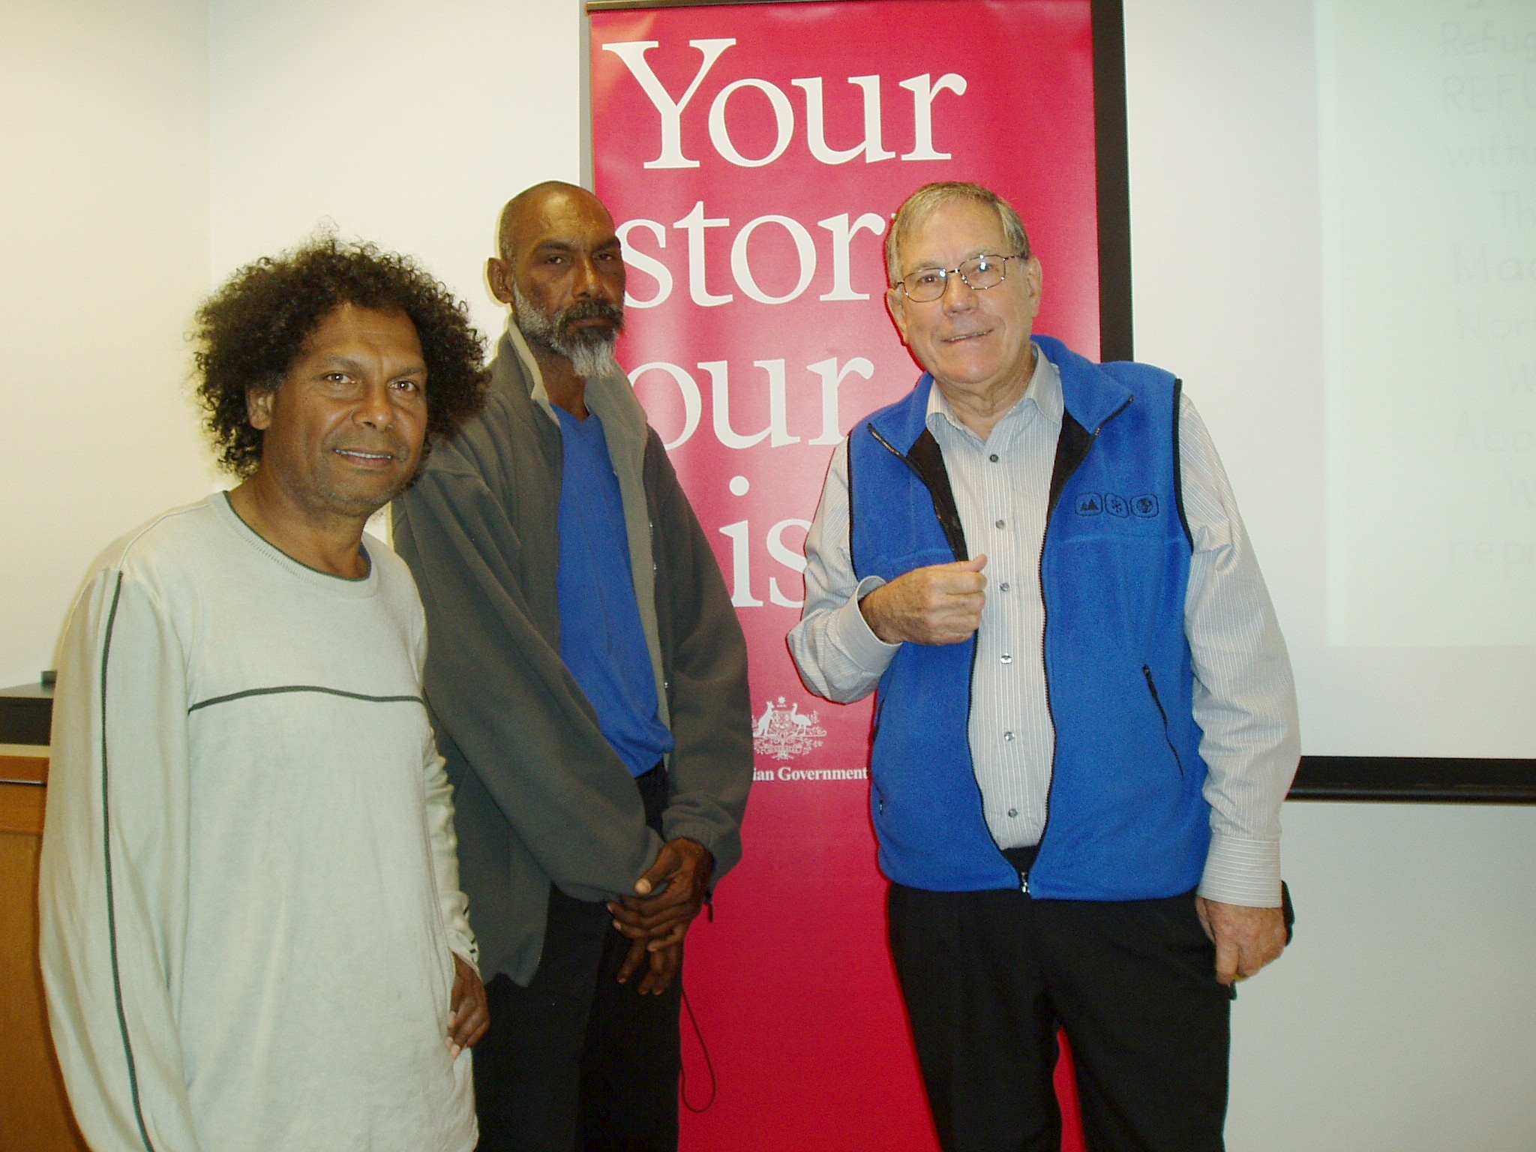
Above: Larrakia man Lennie May and petition. Right: Lennie May, Daniel May and Bill Day at National Archives of Australia in Canberra on 29th May 2011.

